

GP5801-02
GPON 2 Port OLT

Product Overview
The GP5801-02 is a highly integrated, medium-capacity GPON OLT designed for carriers, ISPs, enterprises, and campus applications. It complies with ITU-T G.984/G.988 technical standards, offering excellent openness, strong compatibility, high reliability, and comprehensive software features. It is widely applicable in network construction for FTTH access by carriers, VPNs, government and enterprise campuses, and campus networks.

The GP5801-02 is a compact 1U-height device, making it easy to install and maintain while saving valuable space. Leveraging industry-leading technology, it offers an efficient GPON solution with optimized bandwidth utilization and robust Ethernet service support, enabling operators to deliver reliable service quality to users. The device also supports mixed networking with various types of ONUs, significantly reducing costs for operators.

Product Interface
GP5801-02
- 2 * GPON port
- 2 * 10/100/1000M Base-T
- 2*1000M Base-X SFP/2*10GE SFP+
- 265 * 180 * 40mm
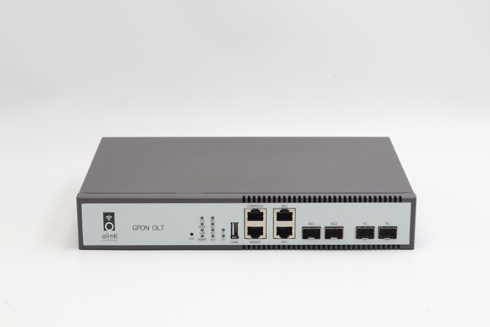
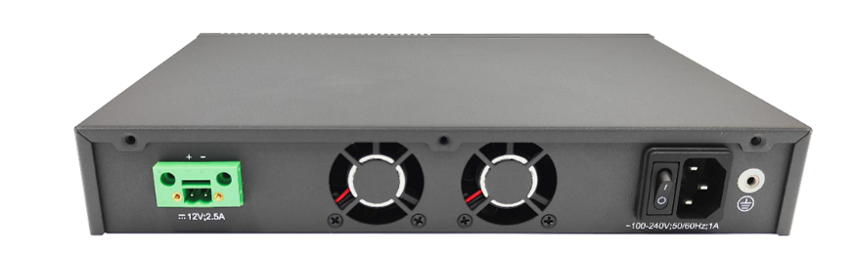

Key Features
- Complies with ITU-T G.984/G.988 technical standards, ensuring strong interoperability.
- Offers rich Layer 2/3 switching features and flexible management options.
- Supports various link redundancy protocols such as FlexLink, STP, RSTP, MSTP, ERPS, and LACP.
- Supports routing protocols including RIP, OSPF, BGP, ISIS, and IPv6.
- Provides redundant power backup.
- Supports terminal power-off alarm notifications.

Hardware Specification
Attributes | GP5801-02
Interface | 2 * GPON port; 2 * 10/100/1000M Base-T;  2*1000M Base-X SFP/2*10GE SFP+; Dual power supply optional
Exchange Capacity | 51.5Gbps
Packet Forwarding Rate | 59.7Mpps
Memory and Storage | Memory: 32MB; Storage: 512MB
Management Port | 1*Console Port; 1*Management Port
PON | Complies with ITU-T G.984/G.988 standards  20 km physical differential distance, 60 km logical distance  1:128 maximum splitting ratio  Standard OMCI management features  Flexibly compatible with any brand of ONT  Supports batch software upgrades for ONUs
Weight | ≤2kg
Fan | 2*Fixed Fans
Power | AC: 100～240V, 47/63Hz；  DC: 12V
Power Consumption | ≤30W
Dimensions  (W *D *H) | 265mm*180mm*40mm
Environment Temperature | Working Temperature：-10℃～55℃  Storge Temperature：-40℃～70℃
Environment Humidity | Operating Humidity: 10%～95% (non-condensing)  Storage Humidity: 10%～95% (non-condensing)
Environment Friendly | China RoHs,、EEE

Software Specification
Attributes | GP5801-02
Vlam | Supports 4K VLAN 802.1Q  Supports dual-tag VLAN functionality, including static QinQ based on ports & flexible QinQ
MAC | Supports 16K MAC address table entries  Supports static MAC address configuration  Supports black-hole MAC address filtering  Supports port-based MAC address limits
Ring Network Protocol | Supports STP/RSTP/MSTP  Supports ERPS Ethernet Ring Protection Switching  Supports Loopback-detection port loopback detection
Port Control | Support two-way bandwidth control  Support port storm suppression  Support 9K Jumbo ultra-long frame forwarding
Port Aggregation | Support static link aggregation  Support dynamic LACP  Each aggregation group supports a maximum of 8 ports
Mirroring | Mirroring
ACL | Supports standard and extended ACLs  Supports time-based (Time Range) ACL policies  Provides flow classification and definition based on IP packet header information such as source/destination MAC address, VLAN, 802.1p, ToS, DSCP, source/destination IP address, L4 port number, and protocol type
Qos | Support flow rate limiting function based on custom business flow  Supports mirroring and redirection functions based on custom business flows  Support priority marking based on custom service flow, support 802.1P, DSCP priority  Remark capability Support port-based priority scheduling function  Support queue scheduling algorithms such as SP/WRR/SP+WRR
Safety | Support user hierarchical management and password protection  Supports IEEE 802.1X authentication/Centralized MAC address authentication  Support Radius & TACACS+ authentication  Support MAC address learning limit  Support blackhole MAC functionality  Supports SSH 2.0, providing a secure encrypted channel for user login  Supports SNMP v3 encrypted management  Supports port isolation, with hardware isolation of messages between ports  Supports broadcast message rate limiting  Supports IP Source Guard, automatically creating an IP+MAC+port+VLAN binding table, and manual binding of table entries  Supports automatic suppression of ARP flooding attacks and ARP spoofing protection  Supports protection against various CPU-targeted DoS attacks and virus attacks at the control plane
Layer 3 Routing | Supports ARP learning and aging  Supports creating Layer 3 VLAN interfaces and configuring static IPv4/IPv6 addresses  Supports static route configuration  Supports RIP/OSPF protocol functions  Supports VRRP protocol functions
System Management | Supports Console/Telnet/SSH 2.0 command-line configuration  Supports configuration management via web browser  Supports FTP and TFTP file upload/download management  Supports SNMP v1/v2/v3  Supports RMON  Supports SNTP clock synchronization  Supports system operation logs  Supports LLDP (Link Layer Discovery Protocol) for neighbor device discovery  Supports 802.3ah Ethernet OAM (Operations, Administration, and Maintenance)  Supports RFC 3164 Syslog functionality  Supports Ping and Traceroute

Purchase Info
Product Name | Product Description
GP5810-02 | 2 * GPON port;  2 * 10/100/1000M Base-T;  2*1000M Base-X SFP/2*10GE SFP+; Dual power supply optional

