GPON OLT Series
Datasheet
1.Product overview
GPON OLT 8PON are highly integrated, medium-capacity GPON OLT for operators, ISPs, enterprises and park Application. The product follows the ITU-T G.984/G.988 technical standard，The product has good openness, strong compatibility, high reliability, and complete software functions. It can be widely used in operators' FTTH access, VPN, government and enterprise park access, campus network access, ETC.
They are only 1U in height, easy to install and maintain, and save space. Supports mixed networking of different types of ONU, which can save a lot of costs for operators.
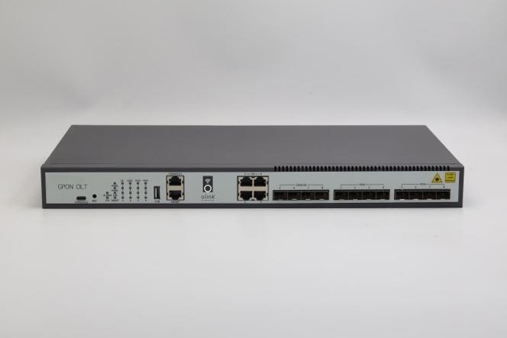
GPON OLT 8PON

2.Main Feature
- Rich Layer 2/3 switching features and Flexible management methods
- Support multiple link redundancy protocols such as Flex-Link/STP/RSTP/MSTP/ERPS/LACP
- Support RIP、OSPF、BGP、ISIS and IPV6
- Safe DDOS and virus attack protection
- Support Power redundancy backup，Modular power supply(8/16PON)
- Support power failure alarm
- Type C management interface(8/16PON)

3. Hardware Features
Attributes | GPON OLT 4PON | GPON OLT 8PON |  | GPON OLT 16PON
Exchange capacity | 103Gbps | 118Gbps |  | 156Gbps
Packet forwarding rate | 76.632Mpps | 87.792Mpps |  | 116.064Mpps
Memory and storage | memory：7168M, storage：2048M
Management port | Console |  | Console， Type C
Port | 4*GPON Port，4*10/100/1000M Base-T,4*1000M Base-X SFP/4*10GE SFP+ | 8*GPON Port，4*10/100/1000M Base-T,4*1000M Base-X SFP/4*10GE SFP+ |  | 16*GPON Port，8*10/100/1000M Base-T,4*1000M Base-X SFP/4*10GE SFP+
weight | 3.5kg | 5kg |  | 6.5kg
fan | Fixed fans（three fans） |  | Fixed fans（four fans）
power | AC： 100～240V 47/63Hz；  DC： 36V～75V；
Power consumption | MAX：50W |  | 75W
environment friendly | China ROHS EEE
Dimensions  (Width * height * depth) | GPON OLT 4PON: 440mm*44mm*200mm  GPON OLT 8PON: 440mm*44mm*260mm  GPON OLT 16PON: 440mm*44mm*320mm
Environment temperature | Working Temperature：-10℃～55℃  Storge temperature：-40℃～70℃
environment humidity | Operating humidity: 10%～95% (non-condensing)  Storage humidity: 10%～95% (non-condensing)

4. Software Features
Attributes | GPON OLT 4PON | GPON OLT 8PON | GPON OLT 16PON
PON | Comply with ITU-TG.984/G.988 standard  20KM transmission distance  1:128 Max splitting ratio  Standard OMCI management function  Open to any brand of ONT  ONU batch software upgrade
VLAN | Support 4K VLAN  Support VLAN based on port, MAC and protocol  Support dual Tag VLAN, port-based static QINQ and fiexible QINQ
MAC | 16K Mac address  Support static MAC address setting  Support black hole MAC address filtering  Support port MAC address limit
ring network protocol | Support STP/RSTP/MSTP  Support ERPS Ethernet ring network protection protocol  Support Loopback-detection port loopback detection
port control | Support two-way bandwidth control  Support port storm suppression  Support 9K Jumbo ultra-long frame forwarding
Port aggregation | Support static link aggregation  Support dynamic LACP  Each aggregation group supports a maximum of 8 ports
Mirroring | Support port mirroring  Support stream mirroring
ACL | Support standard and extended ACL  Support ACL policy based on time period  Provide flow classification and flow definition based on IP header information such as source/destination MAC address, VLAN, 802.1p, TOS, DSCP, source/destination IP address, L4 port number, protocol type, etc.
QoS | Support flow rate limiting function based on custom business flow  Supports mirroring and redirection functions based on custom business flows  Support priority marking based on custom service flow, support 802.1P, DSCP priority Remark capability Support port-based priority scheduling function,  support queue scheduling algorithms such as SP/WRR/SP+WRR
Safety | Support user hierarchical management and password protection  Support IEEE 802.1X authentication  Support Radius&TACACS+ authentication  Support MAC address learning limit, support black hole MAC function  Support port isolation  Support broadcast message rate suppression  Support IP Source Guard Support ARP flood suppression and ARP spoofing protection  Support DOS attack and virus attack protection
Layer 3 | Support ARP learning and aging  Support static route  Support dynamic route RIP/OSPF/BGP/ISIS  Support VRRP
System management | CLI、Telnet、WEB、SNMP V1/V2/V3、SSH2.0  Support FTP,TFTP file upload and download  Support RMON  Support SNTP  Support system work log  Support LLDP neighbor device discovery protocol  Support 802.3ah Ethernet OAM  Support RFC 3164 Syslog  Support Ping and Traceroute

5.Purchasing Information
Product name | Product description
GPON OLT 8PON | 8*PON port, 4*10GE/GE SFP +4GE RJ45 uplink port, Dual power with optional

